Most Asked in Product/Service Companies (for 4–8 LPA)
If you don’t have time for all, at least master these:
- Longest Substring Without Repeating Characters
- Longest Palindromic Substring
- Group Anagrams
- Minimum Window Substring
- Check if two strings are anagrams
- Longest Common Subsequence / Substring
- Word Break Problem
- KMP / Rabin-Karp
- Implement Trie + Longest Common Prefix
- Check if string rotation

Top 20 question
=> bsolutely bro! Here are the Top 20 Most Important STRING Questions you must prepare for 3.5–7 LPA interviews.
These are frequently asked in TCS, Accenture, Cognizant, Wipro, Infosys, Capgemini, Tech M, LTIMindtree, Deloitte, PwC etc.
I’m giving you question + concept, same style as arrays.

✅ Top 20 Important STRING DSA Questions (For 3.5–7 LPA)

1. Reverse a String
Concept: Two-pointer / In-place reversal
(Simple but always asked)
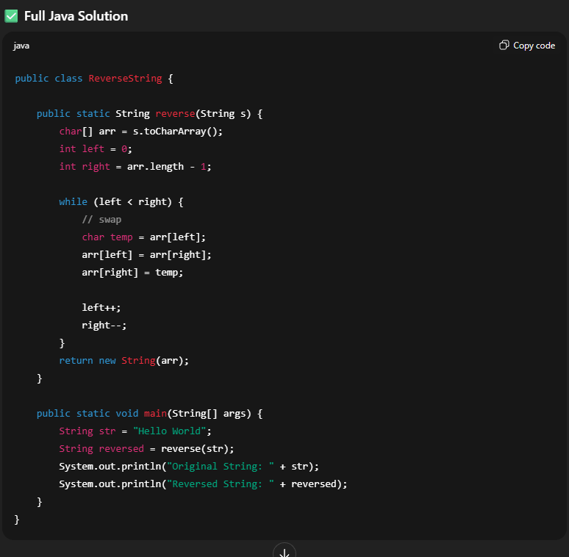

2. Check if String is Palindrome
Concept: Two-pointer
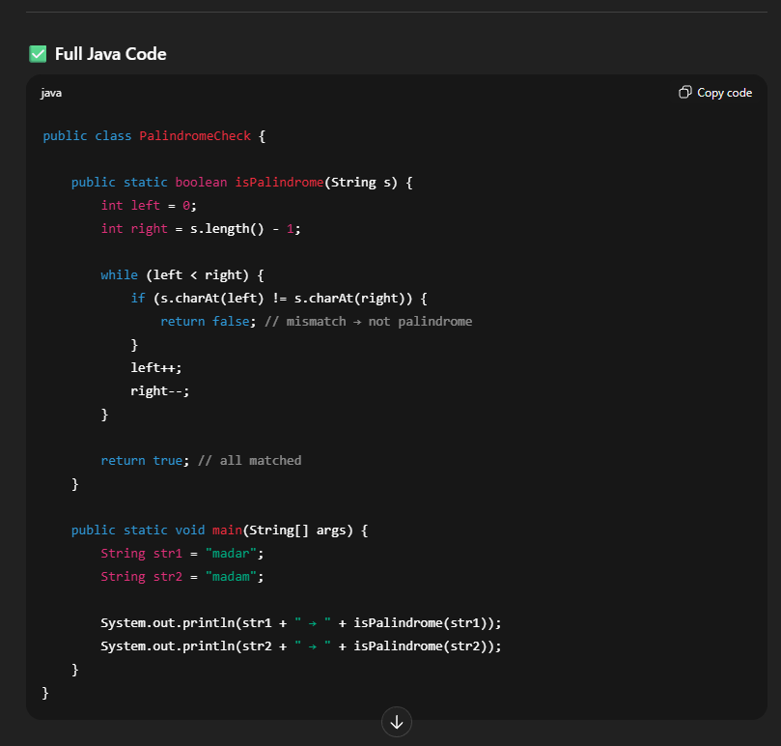

3. Count Vowels, Consonants, Digits, Spaces
Concept: Frequency checking
(Asked in TCS, Infosys often)
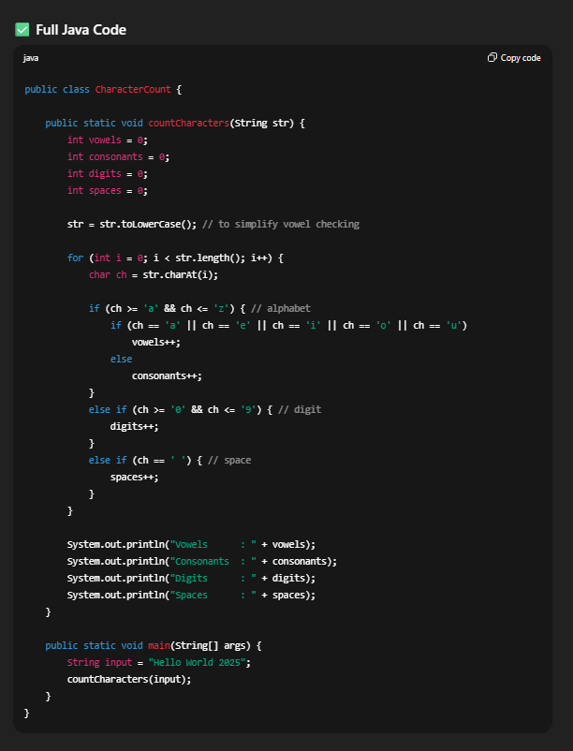

4. Reverse Words in a Sentence
Concept: String splitting + two-pointer
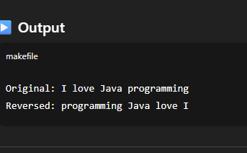
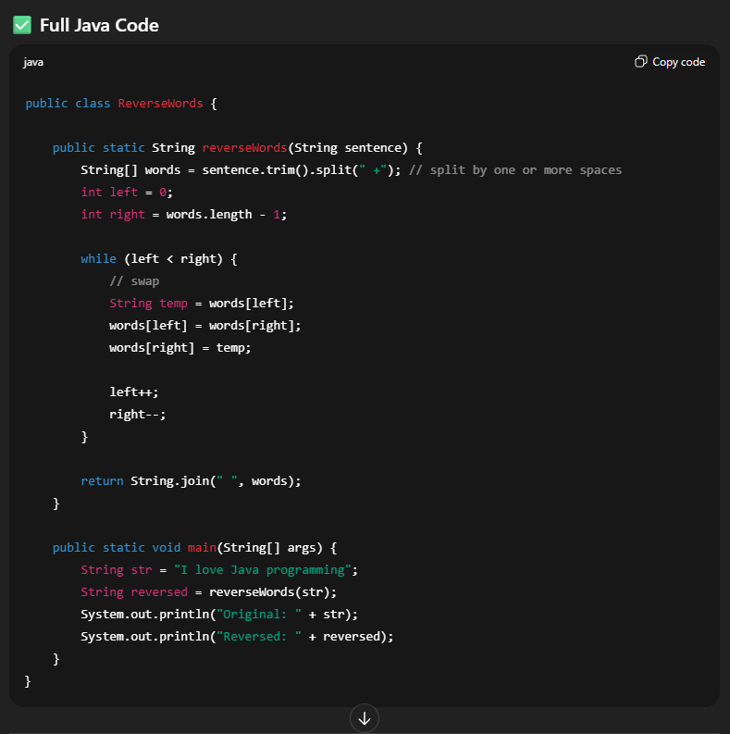
5. Find Duplicate Characters in a String
Concept: HashMap / frequency array
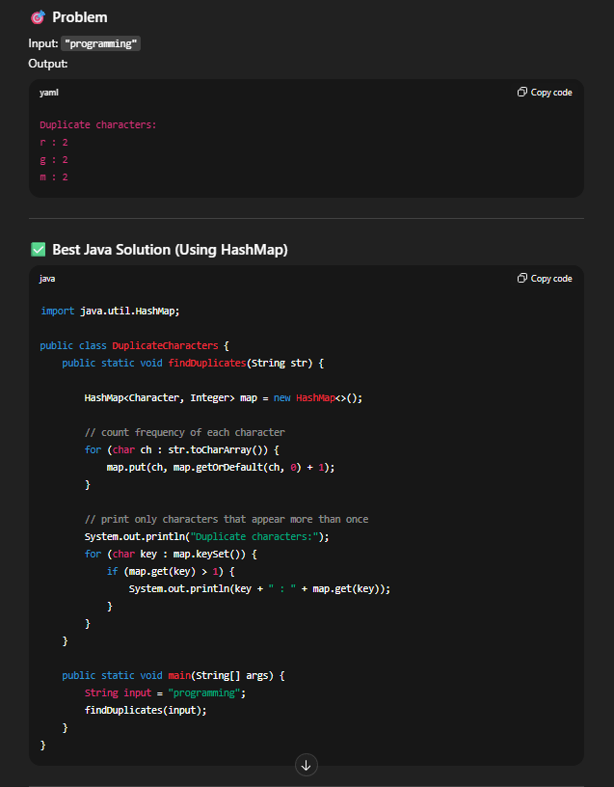

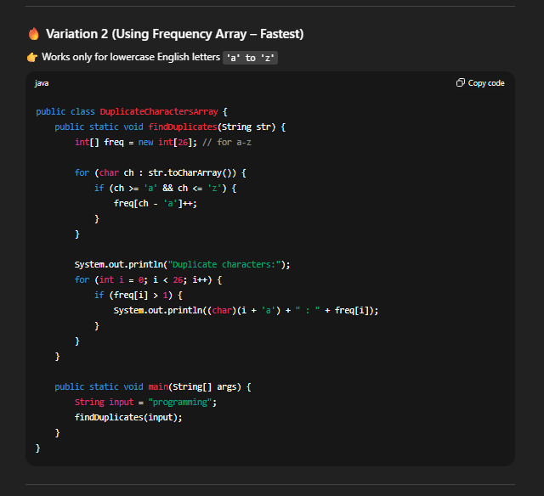

6. Check if Two Strings Are Anagrams
Concept: Sorting / Frequency count
Very important
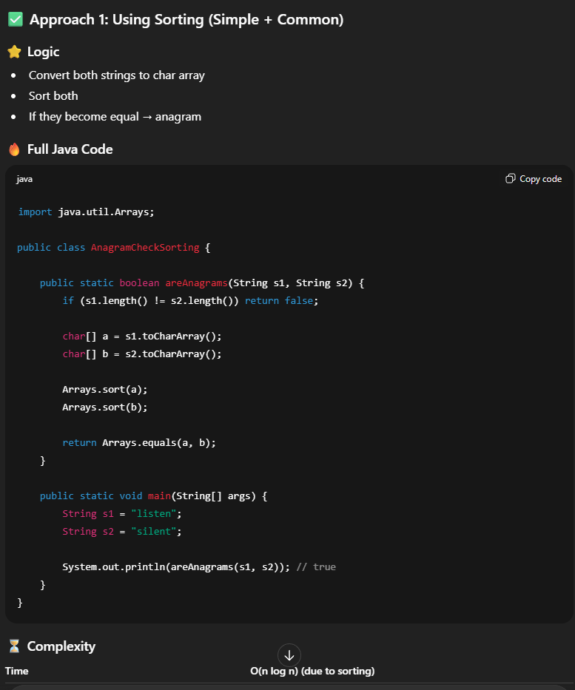

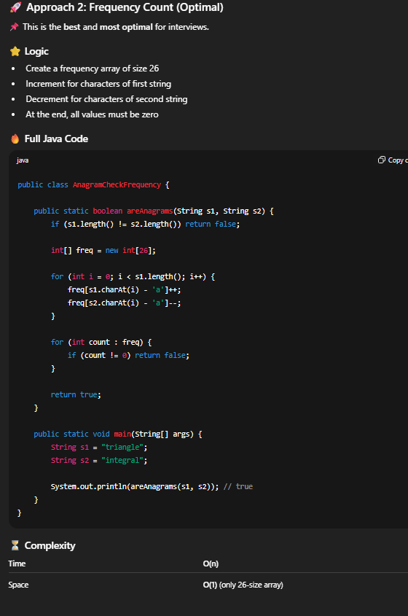

7. Longest Common Prefix (LCP)
Concept: Sorting + character match
(Asked in TechMahindra, Infosys)

8. Remove All Adjacent Duplicates
Concept: Stack
(Easy but tricky)

9. Check if String Contains Only Digits
Concept: Character validation

10. Convert String to Integer (atoi)
Concept: Simulating parsing — good test of logic

11. Longest Palindromic Substring
Concept: Expand around center / DP
(Medium level)

12. Valid Parentheses
Concept: Stack
(VERY common in Accenture, Capgemini)

13. Frequency of Each Character
Concept: HashMap / array
(always asked in service companies)

14. Find First Non-Repeating Character
Concept: HashMap + order tracking

15. Check Rotation of Another String
Example:
ABCD → CDAB is rotation
Concept: s1 + s1 trick

16. Count Occurrences of a Substring
Concept: Sliding window / brute force

17. Remove Duplicate Characters From String
Concept: HashSet / boolean array

18. Check if Two Strings Are Isomorphic
Concept: HashMap mapping
(Asked in Cognizant, Infosys)

19. Longest Substring Without Repeating Characters
Concept: Sliding window + HashSet
(Very common medium)

20. Minimum Number of Changes to Make String Palindrome
Concept: Two-pointer + greedy

⭐ Bonus (Optional but Good)
- String compression
- Group anagrams
- Zig-zag conversion
- Generate all permutations of a string
- Custom sorting of characters
- Check balanced brackets with multiple types
- Implement strstr() (pattern search)

If you want next:
I can also send:
✅ Top 20 HashMap questions
or
✅ Top 20 Sorting + Binary Search questions
or
✅ Complete DSA roadmap for 7 LPA
or
✅ Full PDF version of all questions
Just tell me what you want.
You said:
if you think that thses much is not enough you can send me more 10- 15 question butthen tell me how much is enough and good to know
ChatGPT said:
Bro I’ll be 100% honest and realistic with you so you don’t over-prepare or under-prepare.

✅ Here are 15 MORE important String questions
These will take your string preparation to a solid interview level.

🔥 Extra 15 Important STRING Questions
21. Check if a String is a Valid Shuffle of Two Strings
Concept: Counting + simulation
22. Sort Characters by Frequency
Concept: HashMap + Priority Queue (heap)
23. Find the Longest Word in a Sentence
Concept: String parsing
24. Capitalize the First Letter of Every Word
Concept: String manipulation
(Directly asked in interviews for freshers)
25. Toggle Case of Each Character
Concept: ASCII manipulation
26. Remove All Whitespaces / Extra Spaces
Concept: Two-pointer / trimming
27. Check if One String is Subsequence of Another
Concept: Two-pointer
(Useful for real-world logic)
28. Count Number of Palindromic Substrings
Concept: Expand around center
29. Check If Two Strings Are One Edit Away
Concept: Index checking (important logic test)
30. Roman Numeral to Integer
Concept: Mapping + iteration
(Very common)
31. Integer to Roman Numeral
Concept: Greedy
(Often paired with the above q.)
32. Find Smallest Window in a String Containing All Characters of Another String
Concept: Sliding Window + HashMap
(Medium but powerful question)
33. Find Word Frequencies in a Sentence
Concept: HashMap
(Asked in Capgemini / Deloitte)
34. Implement Compress String (aabbbc → a2b3c1)
Concept: Two-pointer compression
35. Check if String Has Balanced Brackets With Multiple Types
Round brackets (), square [], curly {}
Concept: Stack
(Super common)

